**Question No :01**

#include<iostream>

using namespace std;

int main(){

int a = 1;

int *ptr = &a;

cout<<"Before"<<endl;

cout<<" F : "<<a<<endl;

cout <<" *Ptr : "<<*ptr<<endl;

cout<<"After\n";

*ptr = 9;

cout<<" F : "<<a<<endl;

cout <<" *Ptr : "<<*ptr<<endl;

delete ptr;

ptr = NULL;

}

**OUTPUT**

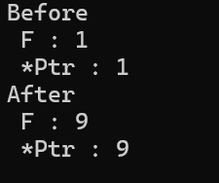

Explaned

It initializes a pointer ptr to point to an integer a, modifies a through the pointer, and prints the results before and after. It also incorrectly uses delete on a non-dynamically allocated variable, which can cause undefined behavior. Lastly, the pointer is set to NULL to avoid a dangling pointer.